FINAL PROJECT REPORT
SMARTPHONE USAGE, ADDICTION & DIGITAL WELL-BEING ANALYSIS

Executive Summary
This project develops an interactive Power BI analytics report for understanding smartphone usage behaviour and digital well-being. The uploaded PBIX file contains a smartphone_usage table and multiple report pages covering usage intensity, sleep, work/study time, gaming, social-media activity, notifications, stress, age group, gender and addiction status.
The report combines KPI cards, slicers, bar/column charts, pie and donut charts, a scatter plot, a decomposition tree and a Key Influencers visual. These components allow users to move from overall KPIs to demographic comparisons and then to possible behavioural drivers.
The analysis is exploratory. The visuals support comparison and pattern identification; they do not by themselves prove causation.

1. Introduction

1.1 Project Overview
Smartphones are used for communication, entertainment, education, work, social networking and many other activities. This project converts smartphone usage records into an interactive Power BI report for examining usage intensity, sleep, study/work time, stress and addiction.

1.2 Objectives
- Analyze daily and weekend screen time.
- Study usage behaviour across age groups and gender.
- Compare gaming, social-media usage, app openings and notifications.
- Examine screen time together with sleep and work/study hours.
- Analyze addiction levels and addicted/non-addicted status.
- Explore stress level and academic/work impact.
- Provide interactive filtering and analytical visuals.

2. Project Initialization and Planning Phase

2.1 Define Problem Statement
Raw smartphone usage records contain many behavioural variables, but individual columns alone do not provide an easy overall view. The project organizes these records into a dashboard that can answer practical questions about usage intensity, addiction, demographics, sleep, stress and daily activities.

2.2 Project Proposal (Proposed Solution)
The proposed solution is an interactive Power BI report with prepared fields, KPI cards, charts, slicers, a decomposition tree and Key Influencers analysis.

2.3 Initial Project Planning
Step | Activity | Purpose
1 | Understand dataset | Identify fields, data types and analytical dimensions.
2 | Data preparation | Check quality, categories and derived fields.
3 | Model/report design | Create calculated categories and report pages.
4 | Visualization | Build KPIs, charts, slicers and analytical visuals.
5 | Validation | Check filters, aggregations and consistency.
6 | Documentation | Prepare insights, conclusions and final report.

3. Data Collection and Preprocessing Phase

3.1 Data Collection Plan and Raw Data Sources Identified
The project is based on the smartphone_usage dataset embedded in the uploaded PBIX file. The Power BI report references the entity smartphone_usage smartphone_usage. The analysis uses user-level and behaviour-related attributes such as age, gender, screen time, sleep, work/study time, gaming, social media, notifications, stress and addiction.

3.2 Data Quality Report
The report uses categorical dimensions and numeric aggregations. A formal row-by-row missing-value audit is not exposed by the PBIX report definition, so this report does not invent missing-value percentages.
Area | Details
Categorical fields | gender, stress_level, addiction_level, addicted_label, academic_work_impact, Age Group, Addicted status
Numeric behaviour fields | age, daily_screen_time_hours, weekend_screen_time, sleep_hours, work_study_hours, app_opens_per_day, gaming_hours, social_media_hours, notifications_per_day
Identifier fields | user_id, transaction_id
Quality checks recommended | Missing values, duplicate IDs, invalid ranges, category spelling and outliers

3.3 Data Exploration and Preprocessing
Two derived categorical fields are visible in the report: Age Group and Addicted status. Numeric variables are aggregated with Count, Average and Sum depending on the visual.

4. Data Visualization

4.1 Framing Business Questions
- How much time do users spend on smartphones each day and on weekends?
- How does screen time vary across age groups and gender?
- How are users distributed across addiction levels and addicted status?
- How do gaming and social-media activities compare?
- How are screen time and sleep displayed together?
- How does stress level relate to app-opening behaviour?
- Which fields are highlighted as possible drivers in the Key Influencers analysis?
- How can filters be used to investigate specific user segments?

4.2 Developing Visualizations
Visual | Fields / Measures | Purpose
KPI cards | Daily screen time, work/study hours, user count, app opens, age, addicted label, weekend screen time, gaming, notifications, sleep, social media | Quick summary
Clustered bar/column charts | Addiction level, gender, age group, stress level and activity measures | Compare groups
Scatter chart | Daily screen time vs sleep hours | Inspect relationship/patterns
Pie/Donut charts | Age group and addiction/addicted status | Show distribution
Decomposition tree | User count by age group, gender, stress, addiction and academic/work impact | Drill into segments
Key Influencers | Usage and demographic fields against addicted status | Explore possible drivers
Slicers | Gender, stress level, addiction level, age group | Interactive filtering

5. Dashboard

5.1 Dashboard Design Screenshot with Insights
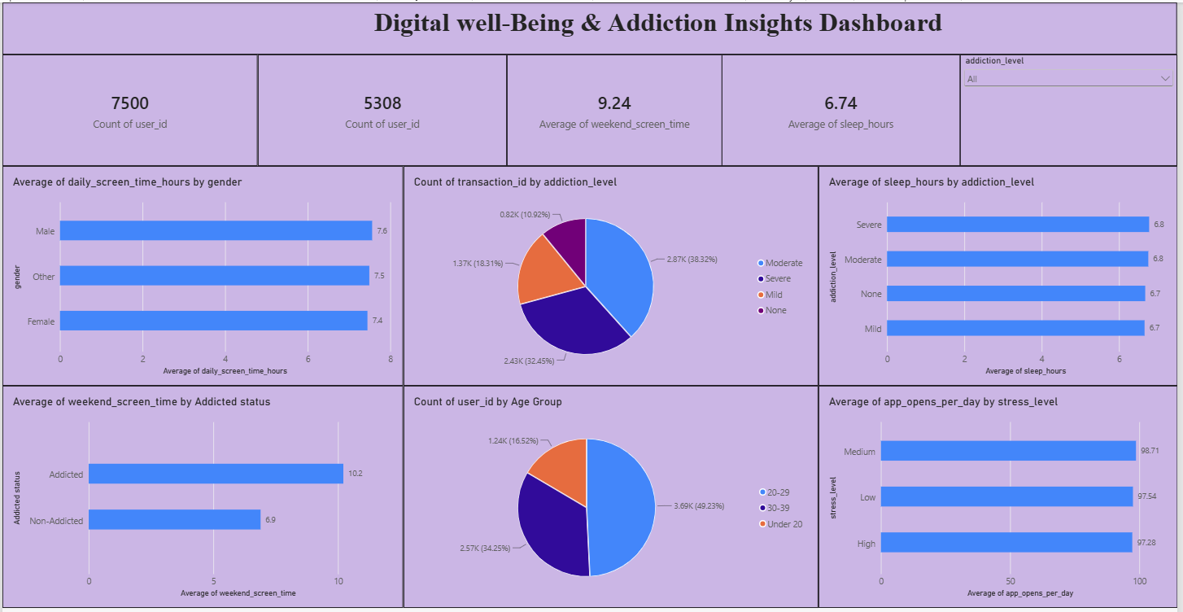
The uploaded PBIX contains a dedicated Dashboard page titled Digital well-Being & Addiction Insights Dashboard. It combines KPI cards, demographic charts, addiction distributions and interactive filtering.
Dashboard area | PBIX visual | Insight supported
Top KPI area | User count / sleep / weekend screen-time cards | Overall snapshot
Demographic section | Age-group and gender charts | Segment comparison
Behaviour section | Stress vs app opens; gender vs screen time | Behaviour comparison
Addiction section | Addiction-level distribution | Category distribution
Filter area | Addiction-level slicer | Focused analysis
Submission note: insert a rendered screenshot of the Dashboard page from Power BI Desktop here if your institution requires an actual screenshot.

6. Report

6.1 Report Design Screenshot with Insights
Report 1 focuses on demographic and addiction segmentation, including a decomposition tree. Report 2 focuses on digital well-being and possible drivers using Key Influencers.

Dashboard
- User count, sleep and weekend screen-time KPI cards
- Age-group and addiction distributions
- Average screen time by gender
- Average app opens by stress level
- Addiction-level slicer

KPI cards
- Average daily screen time
- Average work/study hours
- User count
- Average app opens per day
- Average age
- Sum of addicted label
- Average weekend screen time
- Average gaming hours
- Average notifications per day
- Average sleep hours
- Average social-media hours

Report 1
- Addiction-level slicer
- Age-group slicer
- Gender distribution
- Charts for usage patterns
- Decomposition tree using age group, gender, stress level, addiction level and academic/work
- Impact
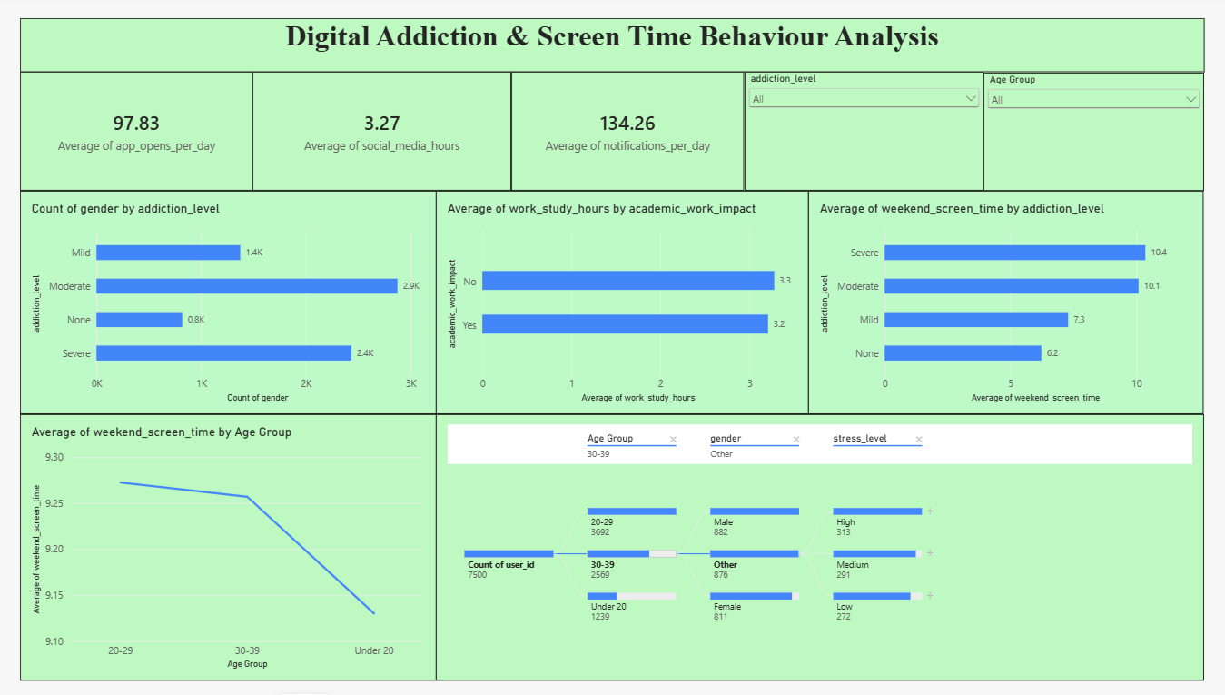

Report 2
- Gender slicer
- Stress-level slicer
- Key Influencers visual
- Charts for screen-time, social-media, gaming and weekend screen-time drivers
- Donut charts and KPI cards
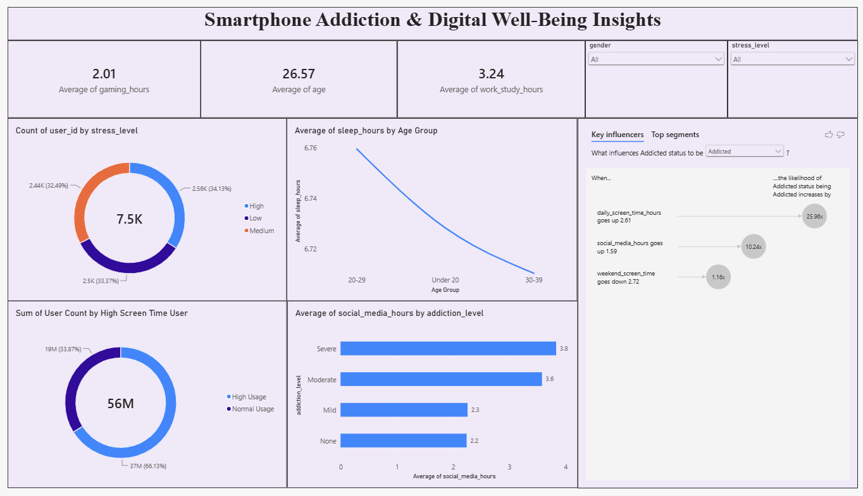

vizualization
- Addiction-level distribution
- Daily screen time versus sleep hours scatter plot
- Gaming versus social-media comparison
- Average screen time by gender
- Average screen time by age group
- Addicted versus non-addicted distribution
Use the slicers first to define a population, then compare KPI cards and charts. The decomposition tree and Key Influencers visual are exploratory analytical tools rather than causal models.

7. Performance Testing

7.1 Utilization of Data Filters
Four distinct slicer/filter dimensions are visible: gender, stress level, addiction level and Age Group. These filters help users move from overall statistics to targeted segments.

7.2 No. of Calculation Columns / Measures
Two derived categorical fields are identifiable: Age Group and Addicted status. No separately named DAX measures are exposed in the report-definition queries inspected; the visuals primarily use direct Count, Average and Sum aggregations.
Item | Result
Derived/calculated fields visible | 2 — Age Group; Addicted status
Explicit named measures visible in report queries | 0 identified
Main aggregations | Count, Average and Sum

7.3 No. of Visuals
The PBIX contains multiple visual types across five pages, including KPI cards, bar/column charts, scatter charts, pie/donut charts, slicers, a decomposition tree, Key Influencers, line charts and text boxes.

8. Conclusion / Observation
The Smartphone Usage & Digital Well-Being project organizes a multi-variable smartphone dataset into an interactive Power BI analytics report. It covers usage time, entertainment behaviour, sleep, work/study, notifications, stress, demographics and addiction.
The combination of descriptive KPIs with interactive segmentation is a key strength. The scatter plot supports relationship exploration between screen time and sleep; demographic charts support group comparisons; and the decomposition tree and Key Influencers visual support deeper investigation.
Because exact rendered result values are not available from the report definition alone, this report intentionally avoids inventing numerical averages, percentages or correlations. Final numerical values should be copied from the refreshed PBIX report.

9. Future Scope
- Add a formal data-quality page showing missing values, duplicates and outliers.
- Create explicit DAX measures for standardized KPIs and percentages.
- Add time-based analysis if a date/time field becomes available.
- Add correlation analysis and trend indicators.
- Add a mobile-friendly report layout.
- Add source and refresh-date documentation.
- Add a validated predictive model for addiction-risk exploration with appropriate ethical safeguards.

10. Appendix

10.1 Source Code (if any)
This project is implemented as a Power BI PBIX report. No separate external source-code file was identified inside the uploaded PBIX package.

10.2 GitHub & Project Demo Link
GitHub Repository: https://github.com/pujitha565/Smartphone-Usage-Digital-Addiction-Well-Being-Analytics
Project Demo / Power BI Link: "E:\project\6.Project executable files\smartphone_usage.pbix"
Add the final public links before submission.

Appendix A – Dataset Fields Identified

Field | Role | Use in analysis
user_id | Identifier | User counting / KPI
transaction_id | Identifier | Record counting
age | Numeric | Age KPI / age grouping
gender | Categorical | Demographic comparison / slicer
daily_screen_time_hours | Numeric | Core usage KPI and comparisons
weekend_screen_time | Numeric | Weekend usage KPI
sleep_hours | Numeric | Sleep KPI / screen-time comparison
work_study_hours | Numeric | Productivity-related KPI
app_opens_per_day | Numeric | Usage intensity
gaming_hours | Numeric | Entertainment behaviour
social_media_hours | Numeric | Social-media behaviour
notifications_per_day | Numeric | Notification intensity
stress_level | Categorical | Stress comparison / slicer
addiction_level | Categorical | Addiction segmentation / slicer
addicted_label | Categorical/numeric label | Addiction status summary
academic_work_impact | Categorical | Decomposition analysis
Age Group | Derived category | Age segmentation
Addicted status | Derived category | Addicted/non-addicted segmentation

Appendix B – Submission Checklist
- Insert student/team details.
- Insert screenshots of Dashboard, Report 1 and Report 2.
- Refresh the PBIX and copy final KPI values if required.
- Add GitHub and project-demo links.
- Verify formatting, page numbers and spelling.

